M1-3200
Manufacturing Tester
LenelS2

Document Change Record
Revision Number | Date: | Description: | Author:
1.0 | 03/27/2022 | Initial | LB
1.1 | 09/01/2023 | Updated | LB
1.2 | 12/27/2023 | Updated per design review | LB

Contents
1. INTRODUCTION 5
2. References 5
3. Testing Station 6
3.1 Test Fixture Box with pogo pins 7
3.2 PC 7
3.3 Label Printer 7
3.4 RS232 to 3.3V serial TTL 7
3.5 4-port USB HUB 7
3.6 Custom test board 7
3.7 USB Pen drive 8
3.8 Barcode scanner 8
3.9. Cabling 8
4. Wiring Map 9
5. SW/FW 11
5.1 M1-3200 12
5.1.2 Bootstrap FW 12
5.1.3 S2 Released FW 12
5.2 Custom Test Board (TB) 12
5.3 PC 13
5.3.1 m1tfd1 Snap 14
5.3.2 m1client Snap 14
6. Theory of operation 15
6.1 ict test 15
6.2 eeprom 15
6.3 progmac 15
6.4 Flash 15
6.5 pingM1apps 15
6.6 makelabel 15
6.7 functest 16
7. Configuration File 16
8. Test Logs 17
1 Logs 17
2 Secrets 17
9. Software and Firmware updates 17
10. Test Vectors 18
10.1 ICT Test 18
1.2 Programming MAC 20
1.3 Programming SSD 20
1.4 Functional Test 20
1.5 Apps Check 21
13. Test Fixture User’s CLI utility 21

List of Tables

Table 1 Supporting Documentation 5
Table 2 Wiring Map 9
Table 3 Parts list 15

List of Figures

Figure 1 System Diagram 6
Figure 2 SW & FW Map 11
Figure 3 Test Fixture inside view 17
Figure 4 Test Fixture open cover view 18
Figure 5 Test Fixture top view 19
Figure 6 PC connections 19

INTRODUCTION

The following document gives an overview of the hardware, software and system configuration for the M1-3200 tester.
The test system is intended to test and program M1-3200 boards. The test system is a standalone system that is connected to a PC. The PC contains software image, diagnostics and serves requests from the M1-3200 under test.

References
The documentation files placeholder link on Teams - M1-3200 Test Fixture

Table 1 Supporting Documentation
Doc # | Document Name | Revision | File | Author
1 | Manufacturing Test Requirements | 2.0 | ManufacturingTestRequirements Rev .docx | Paul Fay
2 | Custom testing board PDF | C | Custom Test Board.PDF | Leo Buchan
3 | M1-3200 bootstrap FW | 0.7 | stm32mp1-baremetal.TMZ | Leo Buchan
4 | Custom testing board FW | 0.9 | M1TestFixtureTeensy41.TMZ | Leo Buchan
5 | PC cloud client SNAP SW | git | m1CloudClient.TMZ | Leo Buchan
6 | PC testing SW SNAP source files, backend test runner and GUI | git | m1tfc.TMZ | Leo Buchan
7 | PC setup | git | PC setup.TMZ | Leo Buchan
8 | Test Fixture user’s guide | 1.0 | M1-3200-TF_users_Guide.docx | Leo Buchan

Testing Station

Figure 1 System Diagram
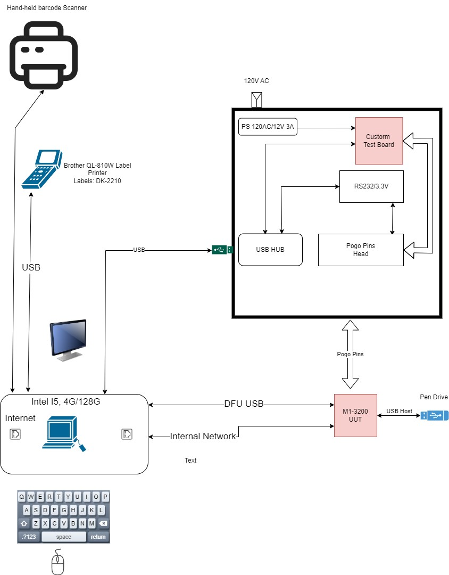

The testing station box consist of the following components:

- Test Fixture box with the POGO pins head to provide connections to BUT, 24AWG stranded wire.
- PC with monitor, keyboard, and mouse.
- Label printer.
- RS232 to 3.3V serial TTL.
- 4-port USB HUB.
- 12V/3A open frame power supply.
- Custom test board.
- USB Pen drive with 1 EXT4 partition, Samsung 128GB.
- 3-D barcode scanner.
- USB mini, micro, and Cat-5 cables

Test Fixture Box with POGO pins

This component to be engineered and built by Saline. The mechanical drawings have been requested from Saline and not yet available. The whole mechanical design must comply with electrical and mechanical applicable safety codes.

3.2 PC

The PC is off the shelf fan-less I5 system with 128GB SSD, 8GB RAM, two Ethernet ports and 4-6 USB ports capable of running Ubuntu 20 (+) operating system.
The PC provides the GUI front end for the operator, runs test cases, programs BUT and manages the testing logs. The PC uses Internet connection to Azure Cloud to store logs, retrieve BUT FW, and automatically update itself. PC shall have all required drivers installed to operate test fixture hardware.

3.3 Label Printer

The label printer is Brother QL-810W(C) label printer. The label with the UIT Product Type, UID, serial #, MAC address is printed when the testing procedure successfully complete, otherwise an Error Label is printed with the failed test name.

3.4 RS232 to 3.3V serial TTL

This is TECH USB to UART TTL Cable, the model is DT-6554.
The cable provides a connection for the serial terminal (J25) on BUT to the PC.

3.5 4-port USB HUB

Only used to reduce USB cables count. Connected to the PC on one end and to the RS232 GUI connector and custom board MCU.

3.6 Custom test board

The custom test board is a custom I/O extension board used to aid the PC in probing the test points voltages, control GPIS and test serial buses. The board has its own firmware and is controlled over the serial link. It uses a Cortex32 ARM processor, bare metals system based on Teensy 4.1 development board.

3.7 USB Pen drive

The USB Pen drive shall be directly plugged into the BUT. It must have a small form factor to fit in to constrained space around BUT J13. Samsung 128 high speed small pen drive is a good choice for this. The drive shall have 1 EXT4 partition on it.

3.8 Barcode scanner

To read Saline serial number from BUT.

3.9. Cabling

Generic USB mini and micro and CAT5 cables.

Wiring Map

Notes:
PP - POGO pin
TB - custom test board
Best - wire connects to
Tolerance - required tolerance to pass

Table 2 Wiring Map
M1-3200 | Wire, Gauge | Best | Name | Voltage Level | Tolerance
PP TP025 | 24-26 | TB J6.2 | M1-3200 Internal VCC | 5V | 5%
PP TP33 | 24-26 | TB J6.7 | MIC VCC_ANGL | 2.9V | 5%
PP TP35 | 24-26 | TB J6.6 | MIC VCC_P3V3_AUX | 3.3V | 5%
PP TP34 | 24-26 | TB J J6.5 | MIC VCC_P3V3 | 3.3V | 5%
PP TP31 | 24-26 | TB J J6.4 | MIC VDD_DDR | 1.1V | 5%
PP TP36 | 24-26 | TB J J6.3 | MIC VDD_CORE | 1.2V | 5%
PP J14.1 | 24-26 | TB J J6.1 | Coin Cell 3.0V backup battery | 3.3V | 15%
PP P3.2 | 24-26 | TB J J6.8 | Boot select, TB OD output | N/A | N/A
PP J5.9 | 24-26 | TB J J5.9 | Ribbon RS-422 | N/A | N/A
PP J5.10 | 24-26 | TB J J5.10 | Ribbon RS-422 | N/A | N/A
PP J5.11 | 24-26 | TB J J5.11 | Ribbon RS-422 | N/A | N/A
PP J5.12 | 24-26 | TB J J5.12 | Ribbon RS-422 | N/A | N/A
PP J5.18 | 24-26 | TB J J5.18 | Ribbon AIO_S0 | Log 0 or 1 | 0.8V/2.7V
PP J5.15 | 24-26 | TB J J5.15 | Ribbon AIO_S1 | Log 0 or 1 | 0.8V/2.7V
PP J5.16 | 24-26 | TB J J5.16 | Ribbon AIO_S2 | Log 0 or 1 | 0.8V/2.7V
PP J5.19 | 24-26 | TB J J5.19 | Ribbon AIO_S7 | Log 0 or 1 | 0.8V/2.7V
PP J5.17 | 24-26 | TB J J5.17 | Ribbon AIO_nest | Log 0 or 1 | 0.8V/2.7V
PP J5.5 | 24-26 | TB J J5.5 | Ribbon VCC_P6V | 6V | 5%
PP J5.7 | 24-26 | TB J J5.7 | Ribbon VCC_P6V | 6V | 5%
PP J5.13 | 24-26 | TB J J5.13 | Ribbon VCC_P12V | 12V | 5%
PP J5.8 | 24-26 | TB J J5.8 | Ribbon VCC_P6V | 6V | 5%
PP J5.14 | 24-26 | TB J J5.14 | Ribbon VCC_P12V | 12V | 5%
PP J5.23 | 24-26 | TB J J5.23 | Ribbon Ground | 0V | 5%
PP J5.25 | 24-26 | TB J J5.25 | Ribbon Ground | 0V | 5%
PP J5.20 | 24-26 | TB J J5.20 | Ribbon Ground | 0V | 5%
PP J5.22 | 24-26 | TB J J5.22 | Ribbon Ground | 0V | 5%
PP J5.24 | 24-26 | TB J J5.24 | Ribbon Ground | 0V | 5%
PP J5.26 | 24-26 | TB J J5.26 | Ribbon Ground | 0V | 5%
PP J07.1 | 24 | TB J J10.1 | Incoming Power 12V | 12V | 5%
PP J07.2 | 24 | TB J J10.2 | Incoming Power Ground | N/A | N/A
PP J08.1 | 24-26 | TB J J9.1 | Tamper Ground | N/A | N/A
PP J08.2 | 24-26 | TB J J9.2 | Tamper Signal | Log 0 or 1 | 0.8V/2.7V
PP J02.1 | 24-26 | TB J J8.1 | Led Blue | -2.6V:-3.3V | 5%
PP J02.1 | 24-26 | TB J J7.1 | Led Red | 1.6V:2.2V | 5%
PP J27.1 | 24-26 | TB J J1.8 | RS-485 DP | N/A | N/A
PP J27.2 | 24-26 | TB J J1.7 | RS-485 DN | N/A | N/A
PP J06.1 | 24 | TB J11.1 | Incoming Battery +12V | >11V | N/A
PP J06.2 | 24 | TB J11.2 | Incoming Battery Ground | N/A | N/A
J13 |  |  | M1-3200 USB Mini RFU port  Connected to PC USB port | N/A | N/A
J11 |  |  | M1-3200 Ethernet port  Connected to PC Ethernet port 1
PP J25.4 | 24 | DT-6554 Pin 4 | Debug Port Rx, DT-6554 is Connected to PC USB port | N/A | N/A
PP J25.5 | 24 | DT-6554 Pin 5 | Debug Port TX, DT-6554 is Connected to PC USB port | N/A | N/A
Teensy 4.1 USB Port |  |  | Connected to PC USB port | N/A | N/A
3-D Scanner |  |  | Connected to PC USB port | N/A | N/A
Label Printer |  |  | Connected to PC USB port | N/A | N/A
PC Ethernet port 2 |  |  | Connected to Internet | N/A | N/A

SW/FW

Figure 2 SW & FW Map

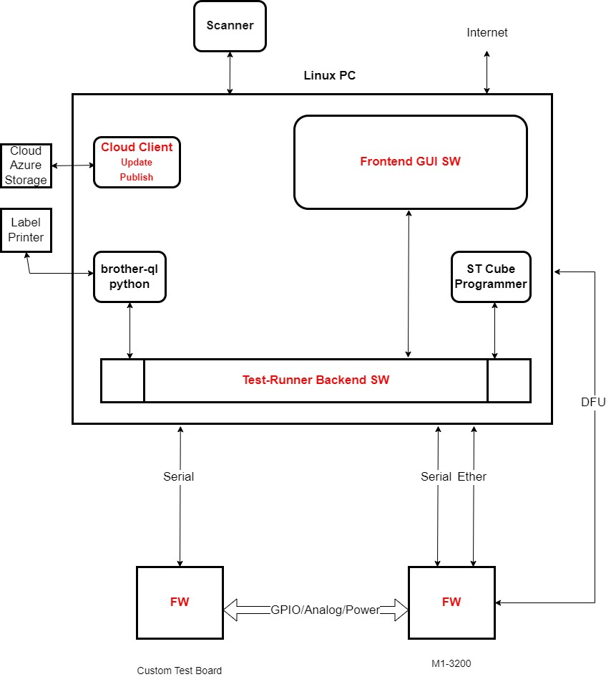

M1-3200

The different firmware is loaded into M1-3200 for different test fixture operations.
Test | FW | Notes
ICT | Bootstrap FW | Loaded from PC to RAM
MAC Program | U-Boot from released FW | Loaded from PC to RAM
Flash | U-Boot from released FW | Loaded from PC to RAM
Fun Test | S2 Released FW | SSD boot
EEPROM Program | Bootstrap FW | Loaded from PC to RAM
Apps Check | S2 Released FW | SSD boot

5.1.2 Bootstrap FW

The Bootstrap FW is the bare metal firmware for STM32MP1 CPU. The communication interface to the CPU running Bootstrap FW is the serial 115200 baud connection over M1-3200 debug serial port. The Bootstrap FW allows the PC to access to any STM32MP1 CPU GPO. Also, Bootstrap FW implements I2C driver for testing I2C buses and I2C EEPROM.

5.1.3 S2 Released FW

The firmware generated by Onto for M1-3200.

Custom Test Board (TB)

The TB is designed with Actium Designer and manufactured by JLCPCB.
MCU is ARM Cortex-M7 IMXRT1062 processor at 600 MHz on add-in Teensy 4.1 development board.
The firmware is written in C++ 14 and downloaded over USB link to the internal FLASH.

The TB populates the same connectors as M1-3200 and the connection is done One-To-One, except J12 Power-In connector which is wired to12.3V/3A power supply. Also, the M1-3200 boot target J6.8, and M1-3200 Rs-485 port are wired to J1.8 and J.7. The terminal block J6 is used to measure the voltages on M1-3200 and connected to M1-3200 corresponding test points.

The are two push buttons switches on the test board. Pressing SW1 will apply or cut the power to M1-3200.The state of SW2 controls the M1-3200 boot target. If the switch is pressed while pressing SW1 the M1-3200 will boot from SSD, otherwise from RAM. This allows easy debugging.

The custom test board is controlled over 115200 baud serial link. The connection to the PC is over micro-USB interface on Teensy 4.1.

Custom test boards are hand tested. The analog inputs are tested with voltages from Table 2. The analog circuitry requires no calibration.
Documentation in provided in a firmware sources, see document #4

Figure 3 Custom Test Board 3d-view
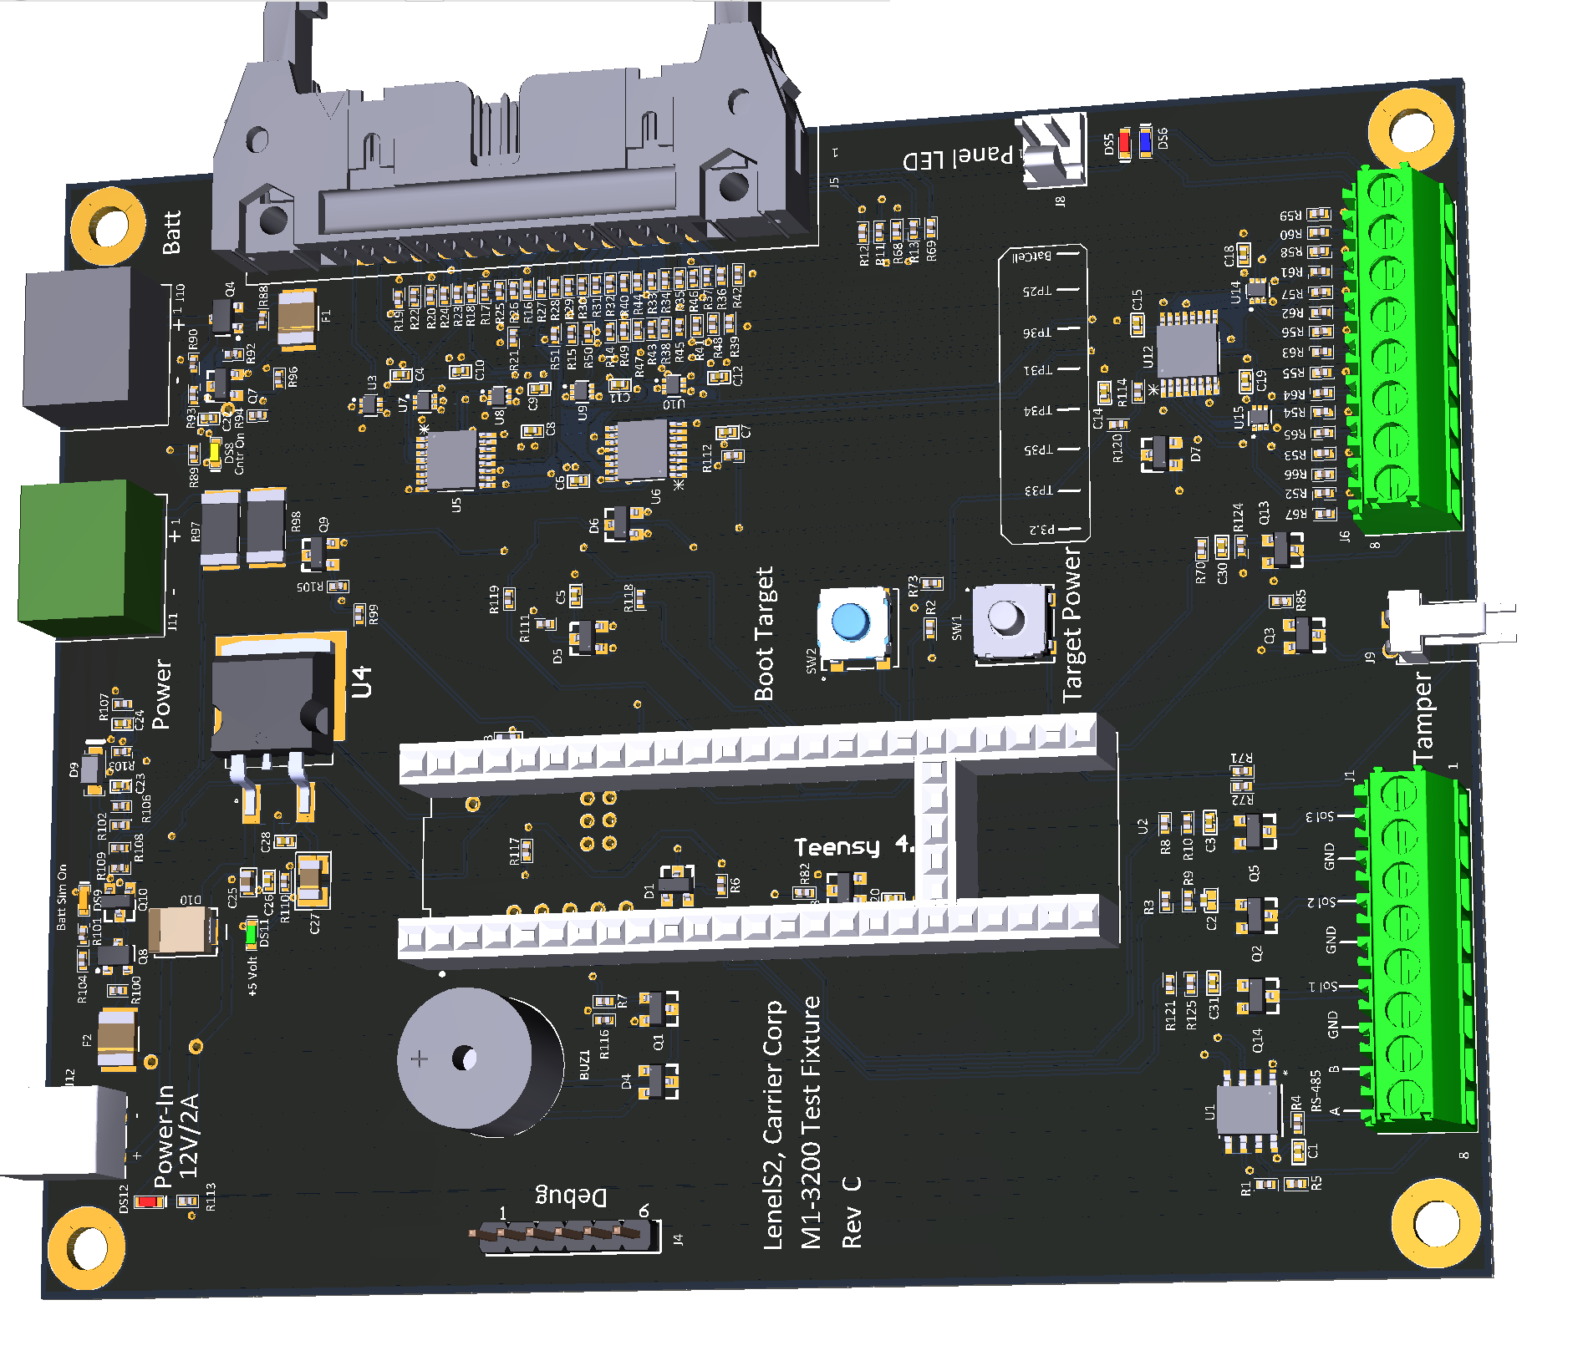

PC

The PC uses the following third-party SW.
- ST Cube programmer – to program STM32MP1.
- Brother python – to control Brother label printer.

Two custom build Ubuntu Snaps are required to run the test fixture.

m1tfd1 Snap

m1tfd1 snap hosts two applications
      - m1tfd1.app - GUI front end app
      - m1tfd1.CLI - Test runner backend

Test runner backend SW is a nodes app and it executes all test fixture operations. GUI frontend app is not required to run test fixture operations since m1tfd1.CLI can be run from the command line.
GUI frontend is a Lazarus application, and it provides an easy graphical interface to the test runner backend SW.

5.3.2 m1client Snap

m1client provides m1client application
m1client application is run from crontab to perform the following tasks

- Publish logs to the Cloud
- Backup the database to the Cloud
- Publish secrets to the Cloud
- Update M1-3200 production Onto FW
- Update PC FW.
- Update STM32MP1 bootstrap FW

lenel@m1testf4:~/M1Combined$ m1client --help
Usage: m1cli [options] [command]

CLI utility retrieve M1-3200 manufacturing logs

Options:
-V, --version output the version number
-h, --help display help for command

Commands:
update [options] download and update software and firmware on the test fixture
synclogs sync logs into Cloud AS
backupdb backup DB to the cloud
syncsecrets sync M1-3200 secrets into Cloud AS
help [command] display help for command
lenel@m1testf4:~/M1Combined$

Big Fat Working:

m1client update will update
- GUI and backend testing software
- M1-3200 bootstrap firmware
- M1-3200 SSD image which is programmed into M1-3200 SSD
- The m1client itself. The m1client cannot update itself, therefore it will download the new version but the actual update is scheduled with crowd to be done 4AM in the morning.
If update is required right away CD to the directory /home/level/ m1mtf/TMP and run the commands below:

#ls -l m1client_*_amd64.snap
#find the latest snap file
#sudo snap install –dangerous –classic m1client_??????_amd64.snap

Theory of operation

The following operations are supported.

ICT - Executes ICT test.
EEPROM - program I2C EEPROM.
Prog mac - program MAC to MP1 OTP, cannot be undone
Flash - program STM32M1 with the flash layout file
pushtocloud - pack the log for specified serial and push tarball to the cloud.
pingM1apps – check if M1-3200 except connection on port 80 and check if s2nn is running.
Cleanup - clean log file and make tarball for the cloud download.
Funniest - m1-3200 function test.
Make label - print the M1-3200 Label.

6.1 ICT test

This is an ICT test. The test board checks selected MIC voltages, incoming and battery power, and M1-3200 5V regulator. The values shall be within 5% or expected values. Then the Bootstrap FW is downloaded to M1-3200 and executed. The m1tfd1.CLI application sets GPIS to the desired level on M1-3200 and checks GPIS with test board A/D. All values shall be within 5% of expected.

6.2 EEPROM

The EEPROM is programmed with Product Type, UID, serial #, and MAC address.
The data is protected with a hash checksum.

6.3 prog mac

U-Boot is downloaded to STP32M1 RAM. ST Cube programmer programs the MAC value into OTP area and data is locked.
If OTP is not blank the operation does not fail, but the user is informed.
The MAC addresses are managed with the help of sqlite3 database on the PC. The database is updated with the MAC address only if programming OTP succeeds. The new Mac address is recorded along with CPU serial number and board manufacturer serial number. The next available MAC address is calculated as the last used 1.
The database record has CPU and manufacturer serial numbers. This ensures no MAC duplicates are programmed. The database file is backup to Azure Cloud every night.

6.4 Flash

ST Cube programmer programs SSD with the flash layout file.

6.5 pingM1apps

Boot M1-3200 from SSD. Check that S2 FW apps are running.

6.6 make label

Prints the M1-3200 label based on the data in EEPROM. The data integrity of EEPROM data is checked.

6.7 funniest

M1-3200 runs from SSD, normal boot. Peripherals functionality is checked.

Configuration File

The default configuration is hard coded in the SW.

{
ictFWFilePath: `${process.env.HOME}/m1mtf/ASBL.stm32`,
m1fwBase: `${process.env.HOME}/m1mtf/stm32mp15-lenels2-m1`,
m1mtfDir: `${process.env.HOME}/m1mtf`,
layoutFilePath: `${process.env.HOME}/m1mtf/stm32mp15-lenels2-m1/flash layout_st-ls2m1-image-core/trusted//Flash Layout_eMMC_stm32mp151f-ls2m1-trusted.TSV`,
programming Command: `${process.env.HOME}/STMicroelectronics/STM32Cube/STM32CubeProgrammer/bin/STM32_Programmer_CLI`,
m1SerialDev: '/dev/ttyUSB0',
m1defaultIP: '192.168.0.251',
testBoardTerminalDev: '/dev/ttyACM0',
Tolerance: 0.05,
Login: 'root',
Password: '*****',
serialBaudrate: 115200,
Construing: 'none',
memTestSize1MBBlocks: 10,
forceEppromOverwrite: false,
vendor Site: 'N1',
skipTestpointCheck: false,
ping Ports: true,
tester Mode: 'commission',
prog EEPROM: true,
make Label: true,
funcTestDisable: false
}

The configuration can be altered by the file /var/snap/m1tfd1/current/config.Jason
The file format is JSON text file.

{
"conString": "DefaultEndpointsProtocol=HTTPS;Account Name=lenels2production;Account Key=QYLAhAvw4SowA6HJqBm2CTkR3Q36PWxfFUPDhqZ4yEyK6lJNb02GEwS/Z/kF8+qMEPs6VAzSnHHt+AStrIr3VQ==;Endpoint Suffix=core.windows.net",
"vendorSite": "p1"
}

Define the following parameters:
Construing - connection string to Azure Storage Account.
vendor Site - required for EEPROM serial number, two characters.

Make sure /var/snap/m1tfd1/current/config.Jason is a valid JSON file or test fixture test runner CLI will not run.

Test Logs

1 Logs

The system logs every process step. Three log levels are available, Error, Info and Debug. The default error log displayed on the screen is Error. Looking into the Info log may help to trouble shoot many issues with the BUT or with the test fixture, like miss-plugged Label printer USB cable. The Debug level is for development purposes.
The log can be found under the directory /home/level/m1mtf/logs
Every BUT has its own subdirectory log. That subdirectory name is BUT Saline serial number.
Change directory to /home/level/m1mtf/logs/[SERIALNUMBER]

Execute #ls -l
The files will be displayed
lenel@m1testf4:~/m1mtf/logs/3023200042$ ls -l
Total 228
-rw-rw-r-- 1 lenel lenel 125490 Aug 4 14:44 3023200042-debug.log
-rw-rw-r-- 1 lenel lenel 22459 Aug 4 14:40 3023200042_dump.log
-rw-rw-r-- 1 lenel lenel 2956 Aug 4 14:44 3023200042-error.log
-rw-rw-r-- 1 lenel lenel 66889 Aug 4 14:44 3023200042-info.log

To display the file execute
# cat 3023200042-info.log

The logs are automatically archived and transmitted to Azure Cloud overnight. The logs from the cloud can be retrieved by logging into the LenelS2 Azure account and by the special CLI utility which was developed as a part of this project.

If the logs and secrets can be pushed to the Cloud from the GUI App Cloud Menu.

2 Secrets

The secrets file is created every night from the information available in the database and transmitted to the azure Cloud in text delimited file format. The information in the file is BASE32 and encrypted with LenelS2 public key.
The secrets file can be retrieved from the cloud by logging into the LenelS2 Azure account and by the special CLI utility which was developed as a part of this project.

3 GUI App Log Level

The GUI App log level default is Error. The log level can be changed with the keyboard shortcut. Press CNRL + Alt + Shift + 0 for the Error log level, Press CNRL + Alt + Shift + 1 for the Info log level. If Debug log level is required press CNRL + M

Software and Firmware updates

The test fixture software and M1-3200 firmware updates are done automatically by the PC. The crontab job will execute an update every night.
The updates are downloaded from the Azure Cloud, the updates integrity hash is checked and then installed.
The updates can be uploaded to the Cloud manually, but it is not advisable because it is error prone. Instead m1CloudClient utility (see below) shall be used to update the Cloud.
The m1CloudClient is a CLI utility which was developed as a part of this project can handle uploading updates to the Cloud and generating the proper manifest file for.
The manifest file describes every update component and hash checksum for.
See an example below.

lenel@m1testf4:~/m1mtf/tmp$ cat manifest File.Jason
[
{
"Filetype": "TMZ",
"Filename": "m1firmware.TMZ",
"Hash": "6aa667ccfe4eca7cc8774b96e85e8b64ce87de8eddc2a0228c9be0beaf8ef971497bfe4d104a327626d99ed145732054997581060d3b6ea254cc988f952860ff"
},
{
"Filetype": "STM",
"Filename": "ASBL.stm32",
"Hash": "ac1efe702294c11dfce1a4e492ef5b56e098b0ab02c53ddec1d56fa35211b2a38e3265e2c06dafbc6086defcea4738e26746f4dde441ed028081b3adcdfc4592"
},
{
"Filetype": "snap",
"Filename": "m1tfd1_8dcc871_amd64.snap",
"Hash": "9ac60485779f1d11d8e7f4643bc7378402bb6878066bf0d177a610a86f2d0be83b1fd1fb05c1695cb338789f50532d8f55b95885334d303cfb7e7478d4ebbe8f"
},
{
"Filetype": "snap client",
"Filename": "m1client_8af40c74_amd64.snap",
"Hash": "0ba269113dbc1270eaf690a36d10aacc68e11d08f9dac98345ecdf4f05484d11d87bf3bd5f102c545d9f42989f44ba66d8cf43bc4ac631198e8672467e752470"
}
]

Test Vectors

ICT Test

Power is applied to M1-3200 with the boot target RFU USB. The PC wait for M1-3200 to show up, then bootstrap FW is downloaded with the help of ST Cube Programmer and executed.
The PC reads FW revision from the test board and M1-3200 bootstrap to ensure that both serial links are connected, then test vectors are executed.

Common issues:
  - PS issue.
  - Bad POGO pin connection.
  - Teensy 4.1 USB link to PC, cable?
  - M1-3200 USB link to PC, cable?
  - Custom test board issue?

Table 4 ICT Test Vectors

# | Description | Acceptance Criteria | Operation | Troubleshooting
1 | Check Voltage on TP025 | Value = +5.0V +- 5% |  | MIC? Shorts on BUT
2 | Check Voltage on TP033 | Value = +2.8 +- 5% |  | MIC? Shorts on BUT
3 | Check Voltage on TP33 | Value = +3.3V +- 5% |  | MIC? Shorts on BUT
3 | Check Voltage on TP34 | Value = +3.3V +- 5% |  | MIC? Shorts on BUT
3 | Check Voltage on TP36 | Value = +1.2V +- 5% |  | MIC? Shorts on BUT
4 | J5.13 | Value = +12V +- 5% |  | PS issue, wiring?
5 | Check Coin Cell Matt | Value = +3.3V +- 10% |  | No battery? BUT? Not fresh battery?
6 | Check Voltage on TP31 | Value = +1.35V +- 5% | MIMIC is programmed for DDR voltage | BUT I2C issue? MIC?
7 | Ribbon J5.15 | BUT set to 1, TB reads1  BUT set to 0, TB read 0 |  | BUT issue
8 | Ribbon J5.16 | BUT set to 1, TB reads1  BUT set to 0, TB read 0 |  | BUT issue
9 | Ribbon J5.17 | BUT set to 1, TB reads1  BUT set to 0, TB read 0 |  | BUT issue
10 | Ribbon J5.18 | BUT set to 1, TB reads1  BUT set to 0, TB read 0 |  | BUT issue
11 | Ribbon J5.19 | BUT set to 1, TB reads1  BUT set to 0, TB read 0 |  | BUT issue
12 | Ribbon J5.3 | BUT set to 1, TB reads1  BUT set to 0, TB read 0 | I2C slave test. BUT slave I2C GPO CL line is toggled between 0 and 1 | BUT issue
13 | Ribbon J5.6 | BUT set to 1, TB reads1  BUT set to 0, TB read 0 | I2C slave test. BUT slave I2C GPO DA line is toggled between 0 and 1 | BUT issue
14 | Ribbon J5.3 | BUT set to 1, TB reads1  BUT set to 0, TB read 0 | I2C master test. BUT slave I2C GPO CL line is toggled between 0 and 1 | BUT issue
15 | Ribbon J5.6 | BUT set to 1, TB reads1  BUT set to 0, TB read 0 | I2C master test. BUT slave I2C GPO DA line is toggled between 0 and 1 | BUT issue
15 | Ribbon J5.5 | Value = +6V +- 5% |  | BUT issue
16 | Ribbon J5.7 | Value = +6V +- 5% |  | BUT issue
17 | Ribbon J5.8 | Value = +6V +- 5% |  | BUT issue
18 | Ribbon J5.13 | Value = +12V +- 5% |  | BUT issue
19 | Ribbon J5.14 | Value = +12V +- 5% |  | BUT issue
20 | Ribbon J5.23 | Value = +0V +- 5% |  | BUT issue
21 | Ribbon J5.25 | Value = +0V +- 5% |  | BUT issue
22 | Ribbon J5.20 | Value = +0V +- 5% |  | BUT issue
23 | Ribbon J5.22 | Value = +0V +- 5% |  | BUT issue
24 | Ribbon J5.24 | Value = +0V +- 5% |  | BUT issue
25 | Ribbon J5.26 | Value = +0V +- 5% |  | BUT issue
27 | Ribbon RS-422 | Echo test on itself |  | BUT issue
28 | Status Red Led | Value 1.6V:2.2V | M1-3200 is set to activate Red Led | BUT issue
29 | Status Blue Led | Value -2.6V: -3.3V | M1-3200 is set to activate Blue Led | BUT issue
30 | Tamper | Value 0 or 1 | TB toggles line 0 and 1, M1-3200 shall detect the proper value
31 | DDR data bus test | No data compare mismatch |  | BUT issue
32 | DDR address bus test | No data compare mismatch |  | BUT issue
33 | DDR data | No data compare mismatch |  | BUT issue
34 | I2C EEPROM | EEPROM is detected and data can read/write | This tests EEPROM and I2C connected to EEPROM | BUT issue
35 | Test BUT can run from battery power only | Battery power is on, Main 12V power off, the BUT CPU no reset |  | BUT issue
36 | Test battery charger | The charging voltage > 13V | Apply 100R load to the battery. | Charging module issue

Programming MAC

BUT is set to RFU mode. U-Boot from S2 released firmware is downloaded with ST Cube Programmer. MAC address is programmed into STM32MP1.

This step can fail if:
- The Saline serial number with this BUT CPU serial number is already in the database. This means that the user did not scan Saline barcode.
- USB cable issue with RFU USB link

Programming SSD

BUT is set to RFU mode. The BUT is programmed with the flash layout file released by S2’ by ST Cube Programmer.

Sometimes ST Cube Programmer fails. Restart the test.
Check USB RFU cable.

Functional Test
BUT started from SSD.
If /home/s2user/test passed flag is set it is cleared and BUT is rebooted. If all tests pass the /home/s2user/test passed file is created.

Common issues:
  - PS issue.
  - M1-3200 USB link to PC, cable?
  - Ethernet Cable connection to PC.
  - Teensy 4.1 USB link issue.

Table 5 Function Test Vectors
# | Description | Acceptance Criteria | Troubleshooting
1 | MAC address verification | Make sure if config report expected MAC address | Not expected to fail
2 | WD Test | Activate WD, wait for reboot, login to BUT | Not expected to fail
3 | SPI Ram Test | Write random data to SPI Ram, Reboot, compare data is the same after reboot | SPI Flash issue
4 | RTC Test | Set RTC, Set Linux date. Make sure values are different. Power is off. Boot BUT. Make sure Linux date is expected value. | BUT issue, RTC Backup battery connection issue.
5 | USB Pen Drive | The drive is mounted and can read and write. | BUT connector issue, USB Pen drive issue HW issue, USB Pen drive incorrect format.
6 | Ribbon I2C test | Master I2C can scan slave I2c | BUY issue

Apps Check

EEPROM is programmed before this test. BUT started from SSD.
Test runner CLI will login into BUT and application status is checked with net stat.

Test Fixture User’s CLI utility

The CLI utility M1CloudClient automates log and secrets retrieval from the cloud and allows engineering to upload the Cloud test fixture and M1-3200 firmware updates. The link to the utility -> M1-3200 CLI Utility

The user shall specify vendor Site or requires test fixture ID as a parameter to the command line utility.
The vendor Site can be found in the test fixture configuration file.

#m1CloudClient –help

Usage: m1cli [options] [command]

CLI utility retrieve M1-3200 manufacturing logs

Options:
-V, --version output the version number
-h, --help display help for command

Commands:
downloadfwsw [options] download software and firmware to the test fixture
getsecrets <timeStamp> get the secrets file from the Cloud
getlog <logId> get the log from the Cloud
listsecrets <date ref> list secrets avaialble in the Cloud
listlogs <date ref> list logs avaialble in the Cloud
help [command] display help for command

To get help for the specific command

#m1CloudClient-linux getsecrets --help
Usage: m1cli getsecrets [options] <timeStamp>

get the secrets file from the Cloud

Arguments:
timeStamp date prefix, the date format is 2023_02_11_16 and used as prefix, so if date = 2023 then all files from 2023 are returned,
if date = 2023_02_11_16 only for this date files are ruturned

Options:
-h, --help display help for command

#m1CloudClient-linux getsecrets --help
Usage: m1cli getsecrets [options] <timeStamp>

get the secrets file from the Cloud

Arguments:
timeStamp date prefix, the date format is 2023_02_11_16 and used as prefix, so if date = 2023 then all files from 2023 are returned,
if date = 2023_02_11_16 only for this date files are ruturned

Options:
-h, --help display help for command

#m1CloudClient-linux getlog --help
Usage: m1cli getlog [options] <logId>

get the log from the Cloud

Arguments:
logId log file name or uid or serial number from the barcode

Options:
-h, --help display help for command

#m1CloudClient-linux listsecrets --help
Usage: m1cli listsecrets [options] <date ref>

list secrets avaialble in the Cloud

Arguments:
date ref date prefix, the date format is 2023_02_11_16 and used as prefix, so if date = 2023 then all file for 2023 are returned, if
date = 2023_02_11_16 only for this date files are ruturned

Options:
-h, --help display help for command

#m1CloudClient-linux listlogs --help
Usage: m1cli listlogs [options] <date ref>

list logs avaialble in the Cloud

Arguments:
date ref date prefix, the date format is 2023_02_11_16 and used as prefix, so if date = 2023 then all file for 2023 are returned, if
date = 2023_02_11_16 only for this date files are ruturned

Options:
-h, --help display help for command

